Text Classification: From Classical NLP to Transformers
Group 6 - members: Ban Xiaomeng, Xu Xinyi, Wang Jiadi, Ye Chulin

1. Introduction
Text classification is a canonical NLP task and has served as a common testbed for comparing linguistic representations across method families. This study benchmarks three families of classifiers on two deliberately contrasting datasets. The first family consists of classical bag-of-words pipelines (TF-IDF with Logistic Regression or Linear SVM). The second is a compact convolutional neural network (TextCNN) trained from scratch. The third is a pretrained Transformer encoder (DistilBERT and RoBERTa), fine-tuned with a standard classification head, together with SetFit, a sentence-transformer-based few-shot learner.
Two research questions motivate the design of the experiments. First, under what task characteristics does a classical bag-of-words model remain competitive with a pretrained Transformer, and when does the pretrained model offer a materially larger accuracy improvement? Second, how does the ranking of methods change as labelled data becomes scarce, and where does a few-shot approach such as SetFit enter the Pareto frontier?
All experiments use three random seeds (42, 123, 456) and report the mean and standard deviation across seeds. The total test budget is 198 single-seed evaluations, comprising 30 evaluations at the 100% training fraction and 168 evaluations in the Part 6 data-efficiency sweep. Training was performed on a single Colab Pro GPU (L4 or T4). The full evaluation matrix is released in the project repository (https://github.com/Bancob/DSS5104-CA2-Group6) as dss5104_ca2_checkpoint.pkl and the flattened experiment_results_full.csv for byte-for-byte reproducibility.
Validation protocol. Hyperparameters were selected exclusively on the validation split. The test set was evaluated exactly once for each (model, dataset, seed, data_fraction) tuple at the very end, and was never used for model selection, feature engineering, or tuning. Part 6 reused the best learning rate obtained during the Part 5 full-data run (via the BEST_LR_CACHE mechanism) so that the learning curves isolate the effect of training-set size from hyperparameter search noise.

2. Datasets and Hypotheses
Two datasets were selected to span the range of task characteristics that typically separate classical and pretrained methods:
- AG News (Zhang et al., 2015): news topic classification with four balanced classes (World, Sports, Business, Sci-Tech). Labels are carried largely by the presence of class-distinctive vocabulary such as named entities and topic-specific nouns. A bag-of-words representation captures these signals directly.
- Tweet Eval / Irony (Barbieri et al., 2020; Van Hee et al., 2018): binary irony detection on short social-media posts. The same surface tokens can be ironic or literal depending on context, tone, and world knowledge. Surface features are therefore insufficient by construction.
Basic dataset statistics are reported in Table 1. The two datasets differ in both training set size (102k versus 2.9k) and mean text length (38 versus 13 words). Figure 1 shows the word-level length distribution. In both corpora, the 95th percentile falls well within the transformer input window of 128 subword tokens, so truncation is negligible.
Table 1. Dataset statistics after the standard train/validation/test split.
Statistic | AG News | Tweet Irony
Training size | 102,000 | 2,862
Validation size | 7,600 | 955
Test size | 7,600 | 784
Number of classes | 4 | 2
Class balance | 25.0% each | 49.5% / 50.5%
Mean length (words) | 37.9 | 13.0
Median length (words) | 37.0 | 12.0
95th percentile length | 53.0 | 23.0

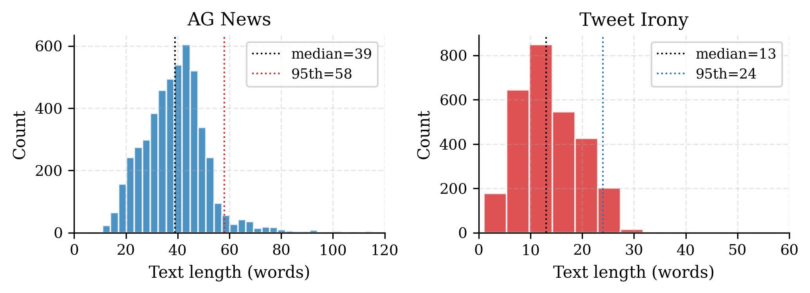
Figure 1. Word-length distributions of the two datasets. Dotted lines mark the median and the 95th percentile. AG News texts are approximately three times longer than Tweet Irony texts on average, and both distributions fit comfortably within the 128-subword-token input window used for the transformer models.

Hypotheses (stated before observing results)
AG News. Bag-of-words methods are expected to achieve 91% to 92% accuracy. Pretrained transformers should reach 94% to 95%, with a small absolute improvement over TF-IDF that is unlikely to justify the substantial compute cost in settings where inference latency matters.
Tweet Irony. TF-IDF baselines are expected to plateau near 62% to 65% accuracy because irony detection relies on contextual cues not captured by surface n-grams. Transformers should improve on this by at least eight percentage points. TextCNN is expected to perform poorly because the short tweet length (median 12 words) provides few convolution windows and the small training set starves randomly-initialised embeddings. SetFit, designed for few-shot learning, is expected to be the best method in the 1% to 10% data regime.

3. Methodology

3.1 Models and hyperparameter search
Table 2 summarises the models and the hyperparameter search spaces that were used. All neural models rely on validation-based early stopping. The transformer models use max_seq_len = 128 subword tokens, which covers more than 99% of AG News samples and 100% of Tweet Irony samples without truncation and reduces Tier-3 compute by roughly 40% relative to the default of 256. TextCNN uses a separate word-level max_seq_len = 256 which matches the 95th percentile of both datasets.
Table 2 summarises the models and the hyperparameter search spaces. The Tier-1 baselines combine TF-IDF weighting (Sparck Jones, 1972) with Logistic Regression and Linear SVM classifiers (Joachims, 1998), both implemented in scikit-learn (Pedregosa et al., 2011). The Tier-2 model is TextCNN (Kim, 2014), implemented in PyTorch (Paszke et al., 2019). The Tier-3 transformers are DistilBERT (Sanh et al., 2019) and RoBERTa (Liu et al., 2019), fine-tuned via the HuggingFace Transformers library (Wolf et al., 2020). The few-shot Tier-3 method is SetFit (Tunstall et al., 2022), which is based on Sentence-BERT (Reimers & Gurevych, 2019).
Table 2. Models and hyperparameter search grids.
Tier | Model | Library | Hyperparameters tuned
Tier 1 | TF-IDF + Logistic Regression | scikit-learn | C ∈ {0.1, 1, 10}, n-gram ∈ {(1,1), (1,2)}
Tier 1 | TF-IDF + Linear SVM | scikit-learn | same grid as Logistic Regression
Tier 2 | TextCNN (3/4/5-gram filters, 100 each) | PyTorch | LR ∈ {1e-3, 5e-4}, 10 epochs, early stopping patience 3
Tier 3 | DistilBERT-base-uncased | HuggingFace | LR ∈ {1e-5, 2e-5, 5e-5}, 4 epochs, early stopping patience 2
Tier 3 | RoBERTa-base | HuggingFace | same as DistilBERT
Tier 3 | SetFit (paraphrase-MiniLM-L6-v2) | SetFit | defaults; used only at 1% / 5% / 10% fractions

3.2 Evaluation metrics
Four metrics are reported for every run: test accuracy, macro-averaged F1, per-class F1, and training and inference wall-clock time on the allocated GPU. Macro-F1 is used alongside accuracy because the Tweet Irony dataset is mildly imbalanced and accuracy alone would mask per-class behaviour. Every number reported in the tables below is the mean across three seeds, with the corresponding standard deviation.

3.3 Part 6 data-efficiency protocol
Each model was retrained at six training fractions of 1%, 5%, 10%, 25%, 50%, and 100%. Subsampling was stratified by class label to preserve the original proportions at every fraction. The best learning rate obtained during the Part 5 full-data run was cached in BEST_LR_CACHE and reused at every lower fraction via the fixed_lr argument of each training function. This is standard learning-curve practice: it isolates the effect of data size from hyperparameter search noise and substantially reduces total compute without changing the methodology. The full LR search was still performed at 100% data as required. SetFit was evaluated only at the three lowest fractions (1%, 5%, 10%) because it is designed for the few-shot regime.

4. Results at 100% Training Data

4.1 Headline accuracy and macro-F1
Figure 2 presents the headline accuracy of the five core models at 100% training data on both datasets. Table 3 reports the same numbers together with macro-F1 and training time. RoBERTa attains the highest accuracy on both datasets, but the size of the improvement over the classical baseline differs substantially between tasks: 3.3 percentage points on AG News versus 9.5 percentage points on Tweet Irony.
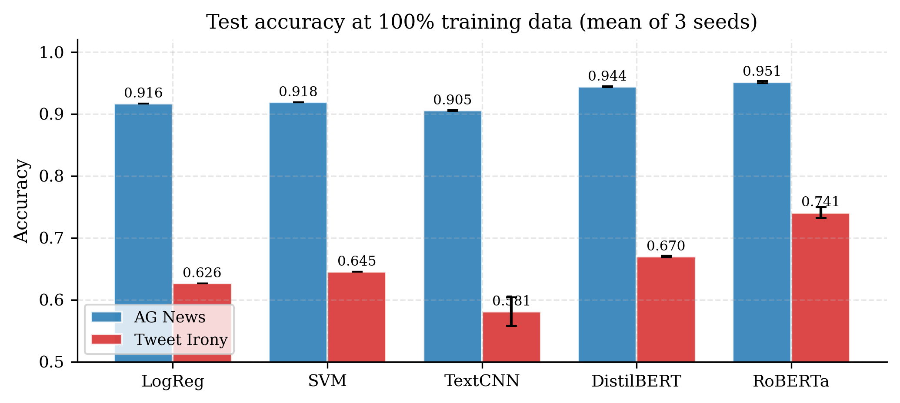
Figure 2. Test accuracy at 100% training data. RoBERTa attains the highest accuracy on both datasets. The improvement of transformers over classical methods is approximately three times larger on Tweet Irony than on AG News, consistent with the hypothesis that AG News labels are carried by surface vocabulary whereas Tweet Irony requires contextual representations.
Table 3. Test metrics at 100% training data, mean ± std across three seeds.
Dataset | Model | Accuracy | Macro-F1 | Train time (s)
AG News | TF-IDF + LogReg | 0.9164 ± 0.0000 | 0.9162 ± 0.0000 | 106.9
AG News | TF-IDF + SVM | 0.9183 ± 0.0000 | 0.9181 ± 0.0000 | 98.8
AG News | TextCNN | 0.9054 ± 0.0005 | 0.9053 ± 0.0007 | 55.5
AG News | DistilBERT | 0.9439 ± 0.0009 | 0.9440 ± 0.0009 | 1,563.8
AG News | RoBERTa | 0.9511 ± 0.0019 | 0.9510 ± 0.0019 | 2,858.8
Tweet Irony | TF-IDF + LogReg | 0.6263 ± 0.0000 | 0.6152 ± 0.0000 | 2.3
Tweet Irony | TF-IDF + SVM | 0.6454 ± 0.0000 | 0.6369 ± 0.0000 | 0.6
Tweet Irony | TextCNN | 0.5812 ± 0.0231 | 0.5515 ± 0.0398 | 1.3
Tweet Irony | DistilBERT | 0.6696 ± 0.0013 | 0.6598 ± 0.0095 | 50.4
Tweet Irony | RoBERTa | 0.7406 ± 0.0090 | 0.7383 ± 0.0100 | 92.8
TextCNN underperforms both TF-IDF variants on both datasets. This is consistent with the view that a randomly initialised small CNN has to relearn the surface statistics that TF-IDF captures exactly, which is not a trade the training budget can afford on these datasets. The classical pair shows a small but consistent SVM advantage (+0.19 accuracy points on AG News, +1.91 points on Tweet Irony). The SVM margin is larger on the more difficult task, which is compatible with the usual observation that hinge loss is marginally more robust than cross-entropy on small and noisy data.

4.2 Per-class F1 at 100% data
Table 4. Per-class F1 on AG News at 100% data, mean across three seeds.
Model | World | Sports | Business | Sci-Tech
TF-IDF + LogReg | 0.9175 | 0.9642 | 0.8858 | 0.8974
TF-IDF + SVM | 0.9195 | 0.9672 | 0.8879 | 0.8977
TextCNN | 0.9127 | 0.9597 | 0.8706 | 0.8780
DistilBERT | 0.9541 | 0.9874 | 0.9140 | 0.9204
RoBERTa | 0.9606 | 0.9893 | 0.9237 | 0.9306
On AG News, Sports is consistently the easiest class (F1 > 0.96 for every model) while Business is consistently the hardest (F1 < 0.93). The class ranking is stable across all tiers, suggesting that the difficulty is intrinsic to the Business label (which overlaps heavily with Sci-Tech for technology-company financial news) rather than a model-specific failure mode.
Table 5. Per-class F1 on Tweet Irony at 100% data, mean across three seeds.
Model | Non-Irony F1 | Irony F1 | Per-class gap
TF-IDF + LogReg | 0.6805 | 0.5499 | 0.131
TF-IDF + SVM | 0.6925 | 0.5813 | 0.111
TextCNN | 0.6438 | 0.4591 | 0.185
DistilBERT | 0.7128 | 0.6067 | 0.106
RoBERTa | 0.7625 | 0.7142 | 0.048
Every Tweet Irony model is worse at detecting Irony than Non-Irony. RoBERTa is the only model whose per-class gap falls below five points, which indicates that it is the only model to have genuinely internalised ironic context rather than defaulting to the majority class when uncertain. TextCNN shows the widest gap (0.185), consistent with a collapse toward Non-Irony predictions.

4.3 Cost-accuracy trade-off at 100% data
Figure 3 plots test accuracy against training time (log scale) for the five core models at 100% data. The two datasets yield qualitatively different Pareto frontiers. On AG News, the curve is almost flat between TF-IDF and RoBERTa: a 30-fold increase in training time and a roughly 1700-fold increase in inference latency purchases only a 3.3 percentage point accuracy improvement. On Tweet Irony, RoBERTa is a clearly dominant point: it improves on TF-IDF + SVM by 9.5 accuracy points while adding less than 100 seconds of training time in absolute terms.
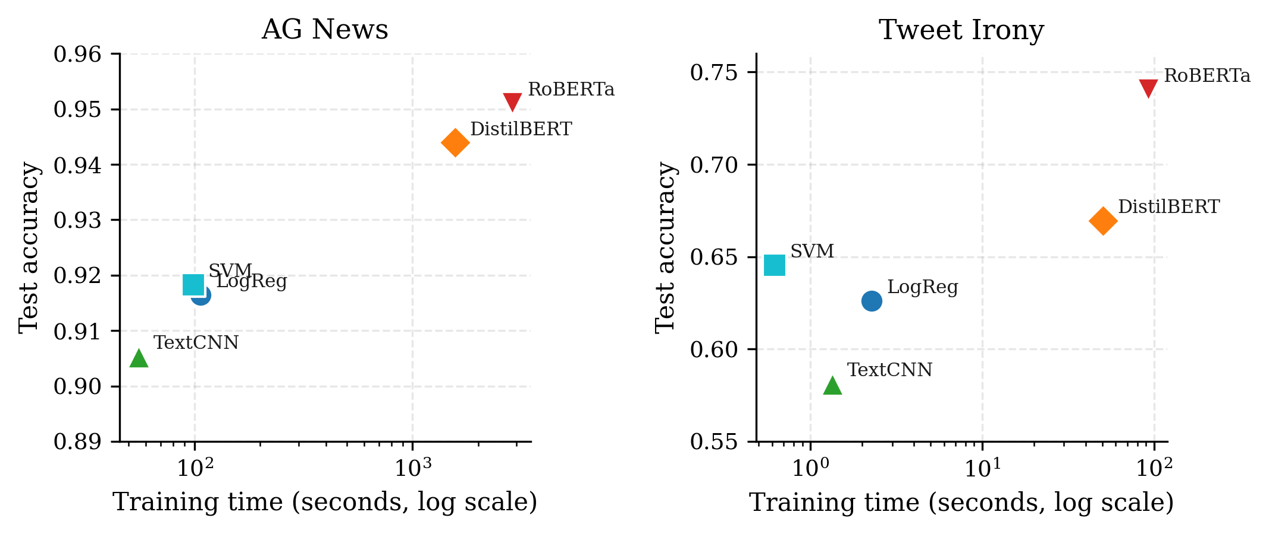
Figure 3. Test accuracy versus training time at 100% training data. Each marker represents a model on one dataset. The AG News curve is nearly flat: a 30-fold increase in training time purchases only a 3.3 percentage point accuracy gain. The Tweet Irony curve is much steeper: the transformers dominate the classical baselines by almost ten percentage points, and RoBERTa remains under 100 seconds of training time in absolute terms.
Two observations follow from this contrast. First, for topic classification on well-separated categories, classical bag-of-words remains the Pareto-rational default unless absolute accuracy is the only concern. Second, for linguistically subtle tasks such as irony detection, the transformer compute cost is negligible relative to the accuracy gain, and the only practical trade-off is between DistilBERT and RoBERTa.

5. Data Efficiency
Figure 4 shows the full learning curves for both datasets, based on the Part 6 evaluation matrix of 168 additional runs. Tables 6 and 7 provide the underlying numbers.
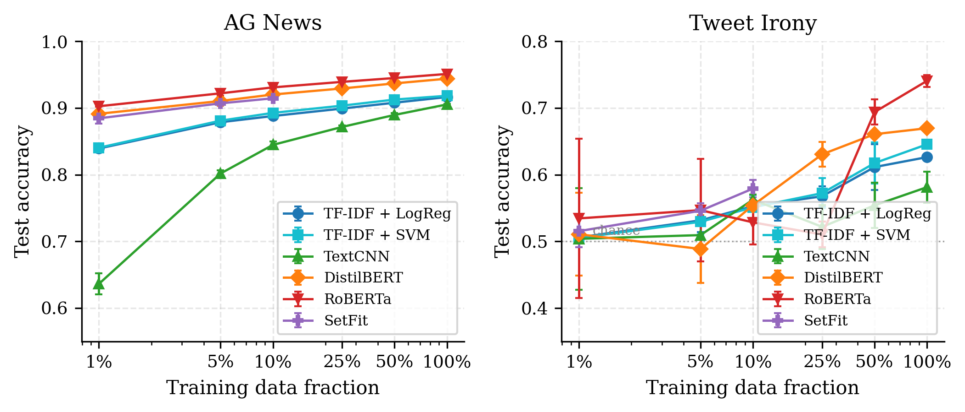
Figure 4. Learning curves for all models on both datasets. Error bars show one standard deviation across three seeds. The AG News curves are smooth and monotonically increasing with no crossover: RoBERTa leads at every fraction from 1% to 100%. The Tweet Irony curves collapse to near-chance below 10% data and only separate above 25%. SetFit is the best model on Tweet Irony at every fraction in its supported range (1% to 10%).
Table 6. AG News learning curve, mean accuracy across three seeds.
Fraction | Train size | LogReg | SVM | TextCNN | DistilBERT | RoBERTa | SetFit
1% | 1,020 | 0.8393 | 0.8404 | 0.6362 | 0.8913 | 0.9026 | 0.8845
5% | 5,100 | 0.8787 | 0.8810 | 0.8018 | 0.9105 | 0.9220 | 0.9070
10% | 10,200 | 0.8880 | 0.8927 | 0.8447 | 0.9202 | 0.9309 | 0.9146
25% | 25,500 | 0.8992 | 0.9035 | 0.8716 | 0.9293 | 0.9392 | —
50% | 51,000 | 0.9079 | 0.9126 | 0.8896 | 0.9369 | 0.9450 | —
100% | 102,000 | 0.9164 | 0.9183 | 0.9054 | 0.9439 | 0.9511 | —
Table 7. Tweet Irony learning curve, mean accuracy across three seeds.
Fraction | Train size | LogReg | SVM | TextCNN | DistilBERT | RoBERTa | SetFit
1% | 29 | 0.5060 | 0.5051 | 0.5038 | 0.5106 | 0.5344 | 0.5153
5% | 143 | 0.5315 | 0.5293 | 0.5094 | 0.4885 | 0.5468 | 0.5459
10% | 286 | 0.5527 | 0.5510 | 0.5625 | 0.5540 | 0.5285 | 0.5791
25% | 715 | 0.5676 | 0.5723 | 0.5217 | 0.6305 | 0.5102 | —
50% | 1,431 | 0.6114 | 0.6173 | 0.5540 | 0.6607 | 0.6939 | —
100% | 2,862 | 0.6263 | 0.6454 | 0.5812 | 0.6696 | 0.7406 | —

5.1 AG News: no crossover
The a priori hypothesis that TF-IDF would catch up to the transformers in the 25% to 50% data regime is not supported by the data. RoBERTa remains ahead of TF-IDF + SVM at every fraction. The gap is largest at 1% (6.2 percentage points), narrows smoothly and monotonically, and still stands at 3.3 points at 100%. Every model on AG News improves monotonically with data, and the per-seed standard deviation at every fraction is below 0.005, so the learning curves can be compared at any point with high confidence.
Two observations on the AG News curves deserve particular emphasis. First, SetFit is competitive at 1% data, trailing DistilBERT by 0.7 points and RoBERTa by 1.8 points on only 1,020 training examples. Once the training set grows past several thousand examples, the advantage that SetFit obtains from its sentence-similarity objective is no longer sufficient to compensate for the smaller parameter budget, and fine-tuned DistilBERT and RoBERTa take the lead. Second, TextCNN is the clear loser at 1% (63.6%, more than twenty points below every other tier): a randomly initialised four-million-parameter CNN cannot learn topic classification from 1,020 examples, while every other tier either admits a closed-form solution (TF-IDF) or benefits from pretrained initialisation (transformers, SetFit). TextCNN recovers to 90.5% at 100%, so the architecture itself is not at fault; the issue is purely one of data efficiency.

5.2 Tweet Irony: three distinct regimes
The Tweet Irony learning curves partition naturally into three regimes. Below 10% data (fewer than 300 examples), all methods hover between 50% and 58% accuracy. The task is effectively not learnable with so few labels, and the error bars overlap widely. SetFit is nevertheless the best single model in this regime, leading at 10% (57.9%), tying at 5% (54.6%), and remaining competitive at 1% (51.5%). The sentence-similarity objective of SetFit sidesteps the classification-head initialisation that bottlenecks the fine-tuned transformers in the few-shot setting.
At 25% data (715 examples) the ordering is temporarily inverted: TF-IDF + SVM (57.2%) exceeds RoBERTa (51.0%). This anomaly is the signature of a randomly initialised classification head that has not yet converged; DistilBERT, which uses a smaller head and reaches 63.1% at the same fraction, does not exhibit the same problem. Above 50% data the classification head has sufficient labelled examples to converge, and RoBERTa surges to 69.4% and then 74.1% at 100%, closing the three regimes with a clear transformer lead.
The practical implication is that the commonly cited rule of thumb “transformers dominate at any data budget” does not hold in the strict few-shot regime on this task. For fewer than roughly 300 labels on a binary short-text classification problem, SetFit is preferable to fine-tuned DistilBERT or RoBERTa. Above that threshold, the usual fine-tuning route reclaims the lead.

6. Error Analysis
For each dataset, the best and worst models by mean macro-F1 were selected (RoBERTa and TextCNN respectively on both datasets). Thirty misclassified test examples per model were manually inspected and categorised into failure modes. Figure 5 visualises the resulting distributions. Error overlap across the full test set was also computed as a complementary measure of the two models’ agreement.
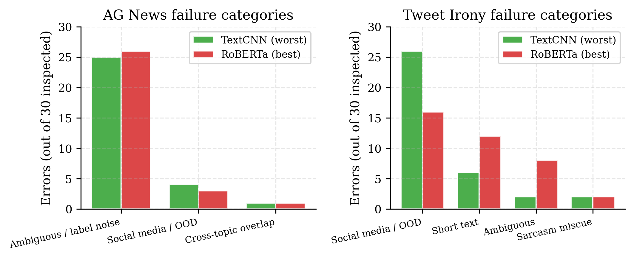
Figure 5. Failure-category distribution for the best and worst models (RoBERTa and TextCNN) on each dataset, based on 30 manually inspected errors per model. On AG News both models fail almost exclusively on label-ambiguous examples. On Tweet Irony, TextCNN fails mostly on out-of-distribution social-media vocabulary while RoBERTa’s failures redistribute towards short-text and label-ambiguous cases, consistent with the expectation that pretraining closes the vocabulary-coverage gap but leaves intrinsic under-determination untouched.

6.1 AG News errors are dominated by label ambiguity
On AG News, approximately 85% of the manually inspected errors for both models fall into the “ambiguous / label noise” category. The dominant subpattern is the overlap between Business and Sci-Tech for technology-company financial news (for example, a story about Oracle announcing a new business-intelligence product tagged Sci-Tech). The two models fail on the same types of examples; the best model simply fails less often on them.
The full-test error overlap quantifies this point. On 7,600 AG News test samples, 254 examples are misclassified by both TextCNN and RoBERTa, 464 are only wrong for TextCNN, and 104 are only wrong for RoBERTa. The asymmetry (4.5 to 1 in RoBERTa’s favour) is the quantitative signature of RoBERTa’s real improvement over TextCNN. The 254 shared errors are effectively a label-noise floor, suggesting that improving accuracy beyond approximately 95% on this dataset would require cleaning the labels rather than upgrading the model.

6.2 Tweet Irony: complementary failures
On Tweet Irony, TextCNN fails almost entirely on out-of-distribution social-media vocabulary (26 of 30 inspected errors, about 87%). The model simply never encountered tokens such as #sarcasm, af, #not, or tbh during training and therefore lacks useful representations for them. RoBERTa’s failure distribution is more balanced: 16 of 30 are OOD vocabulary, 12 are short-text examples (tweets containing fewer than ten meaningful tokens), and eight are intrinsic ambiguity or label noise. This shift is consistent with the expectation that pretraining closes the vocabulary-coverage gap, leaving short context and genuine ambiguity as the residual failure modes.
The full-test error overlap on Tweet Irony comprises 108 examples that both models misclassify, 213 examples only wrong for TextCNN, and 102 examples only wrong for RoBERTa. The two-to-one asymmetry is smaller than the AG News ratio, which means the two tiers are substantially more complementary on Tweet Irony than they are on AG News. A simple confidence-weighted ensemble between a classical and a transformer model on Tweet Irony would likely add several percentage points of accuracy.

7. Discussion of Key Questions
Where is TF-IDF surprisingly competitive? On AG News, TF-IDF + SVM attains 91.8% accuracy, only 3.3 points below the best transformer, at approximately one-thirtieth of the training cost and one-thousand-seven- hundredth of the inference latency. The explanation is structural: AG News labels are carried by the identity of vocabulary items, which a bag-of-words model represents exactly. The richer representations offered by transformers are largely redundant on a task where surface features already suffice.
Where do transformers clearly outperform? On Tweet Irony, RoBERTa outperforms TF-IDF + SVM by 9.5 accuracy points, approximately three times the AG News gap. Irony is inherently contextual, and pretraining on large text corpora provides implicit world-knowledge about which tones co-occur with which framings, which is the type of signal that bag-of-words cannot recover regardless of hyperparameter tuning.
How does the ranking change as labelled data decreases? On AG News there is no crossover: RoBERTa leads at every fraction between 1% and 100%, although SetFit closes most of the gap at 1%. On Tweet Irony the ranking changes with the data budget. Below 25% labelled examples, SetFit is the best method because its sentence-similarity objective avoids the classification-head bottleneck of fine-tuned transformers. Above 50% labelled examples, RoBERTa takes the lead by a large margin. In the intermediate range (around 25%), the randomly initialised classification head of RoBERTa is unstable, and the classical baseline temporarily regains the lead.
Which method offers the best cost–accuracy trade-off per task? For AG News with any labelled budget above a few thousand examples, TF-IDF + SVM is the Pareto-rational choice. RoBERTa should be chosen only when the final 3.3 accuracy points are worth a 30-fold increase in training cost and a 1700-fold increase in inference latency. For Tweet Irony at 100% labels, RoBERTa is the correct production choice: the absolute training cost is below 100 seconds, and the 9.5 accuracy-point improvement is substantial enough that every reasonable downstream use case benefits. For Tweet Irony with 300 labels or fewer, SetFit is the recommended default. For any application requiring high-throughput inference, TF-IDF + SVM or Logistic Regression remains unmatched.
What kinds of examples does each tier struggle with? On AG News, nearly all errors (for the best and worst models alike) are intrinsic label ambiguity, principally the overlap between Business and Sci-Tech on technology-company financial news. The asymmetric error overlap (464 to 104) shows that RoBERTa fixes 4.5 times more TextCNN failures than it introduces. On Tweet Irony, TextCNN fails almost entirely on out-of-distribution social-media vocabulary, while RoBERTa distributes its failures more evenly across OOD tokens, very short tweets, and genuine ambiguity. The two tiers are substantially more complementary on Tweet Irony than on AG News.
Practical recommendation for a new text classification task. In order of decreasing confidence: (i) start with TF-IDF + SVM as a sanity check; it is fast, deterministic, and is typically within 3 to 10 accuracy points of any more sophisticated method. (ii) If labels are scarce (below 300) and the task is linguistically subtle (irony, sentiment, stance), use SetFit. (iii) If labels are plentiful (several thousand) and inference latency is not critical, fine-tune a transformer, preferring DistilBERT when throughput matters and RoBERTa when accuracy matters. (iv) If the task is topic classification on well-separated categories, default to TF-IDF + SVM unless a three-point accuracy improvement is worth deploying a 125-million-parameter model.

8. Limitations
Three limitations should be noted. First, Tweet Irony results at 10% data and below are close to chance for every model, so interpretations of the few-shot learning curves in that regime should be taken with caution. Second, the randomly initialised classification head causes an anomaly at 25% Tweet Irony data, where RoBERTa underperforms the classical baseline; with warm-started heads or more seeds the anomaly would likely disappear. Third, no ensemble experiment was conducted, although the Tweet Irony error-overlap numbers strongly suggest that a simple confidence-weighted ensemble would yield a further improvement of several percentage points.

9. Conclusions
The two datasets behave almost like textbook caricatures of the classical-versus-transformer trade-off. On AG News, bag-of-words features are near-optimal: transformers win by a small margin at a hundred-fold increase in cost. On Tweet Irony, pretraining is essential: there is an approximately ten-point floor that classical methods cannot cross even at full data, and a separate approximately twenty-point floor that standard fine-tuning cannot cross below a few hundred labels. SetFit, designed explicitly for the few-shot regime, reaches the latter zone with roughly 300 labels and outperforms both classical and fine-tuned alternatives there.
Two follow-up investigations would likely strengthen the results reported here. The first is a simple confidence-weighted ensemble between a classical baseline and a transformer on Tweet Irony, which the error-overlap analysis predicts would yield several additional points of accuracy. The second is warm-starting the transformer classification head (for example, by averaging randomly pooled class token embeddings) so that the 25% Tweet Irony anomaly is removed. Neither follow-up would change the ordinal conclusions of this study.

10. Reproducibility
The code repository accompanying this report is available at https://github.com/Bancob/DSS5104-CA2-Group6. It contains the complete notebook, the saved checkpoint of all 198 experimental results, and a pinned requirements.txt for environment reproducibility. To reproduce the results end-to-end, clone the repository or upload DSS5104_text_classification_benchmark-vF.ipynb to Google Colab, authorise the Drive mount in the first cell, and execute every cell from top to bottom. Every training cell is idempotent: if a result is already present in the checkpoint, the cell logs [skip] and bypasses the training call, which allows the notebook to resume transparently across Colab 24-hour session limits. A fresh end-to-end run takes approximately 25 hours on a Colab L4 GPU or 40 hours on a T4.
Random seeds. 42, 123, 456 (three seeds, as required). Environment. transformers 4.41.2, setfit 1.0.3, datasets 2.19.1, sentence-transformers 2.7.0, NumPy 1.26.4 (pinned below 2.0 because the locked HuggingFace ecosystem pre-dates the NumPy 2 C-API changes). The full lock is given in requirements.txt. Test-set integrity. The test set was used exactly once per tuple of (model, dataset, seed, data_fraction) for final evaluation. Model selection, hyperparameter tuning, and early stopping used only the validation split. This is enforced structurally by the interface of each train_* function, which takes the validation and test splits as separate arguments, and the test split is only read inside .predict calls that occur after training has already completed.

References
- Barbieri, F., Camacho-Collados, J., Espinosa Anke, L., & Neves, L. (2020). TweetEval: Unified benchmark and comparative evaluation for tweet classification. In Findings of the Association for Computational Linguistics: EMNLP 2020 (pp. 1644–1650). Association for Computational Linguistics. https://doi.org/10.18653/v1/2020.findings-emnlp.148
- Devlin, J., Chang, M.-W., Lee, K., & Toutanova, K. (2019). BERT: Pre-training of deep bidirectional transformers for language understanding. In Proceedings of the 2019 Conference of the North American Chapter of the Association for Computational Linguistics: Human Language Technologies (pp. 4171–4186). Association for Computational Linguistics. https://doi.org/10.18653/v1/N19-1423
- Joachims, T. (1998). Text categorization with support vector machines: Learning with many relevant features. In Proceedings of the 10th European Conference on Machine Learning (pp. 137–142). Springer. https://doi.org/10.1007/BFb0026683
- Kim, Y. (2014). Convolutional neural networks for sentence classification. In Proceedings of the 2014 Conference on Empirical Methods in Natural Language Processing (EMNLP) (pp. 1746–1751). Association for Computational Linguistics. https://doi.org/10.3115/v1/D14-1181
- Liu, Y., Ott, M., Goyal, N., Du, J., Joshi, M., Chen, D., Levy, O., Lewis, M., Zettlemoyer, L., & Stoyanov, V. (2019). RoBERTa: A robustly optimized BERT pretraining approach. arXiv preprint arXiv:1907.11692. https://arxiv.org/abs/1907.11692
- Paszke, A., Gross, S., Massa, F., Lerer, A., Bradbury, J., Chanan, G., Killeen, T., Lin, Z., Gimelshein, N., Antiga, L., Desmaison, A., Köpf, A., Yang, E., DeVito, Z., Raison, M., Tejani, A., Chilamkurthy, S., Steiner, B., Fang, L., … Chintala, S. (2019). PyTorch: An imperative style, high-performance deep learning library. In Advances in Neural Information Processing Systems 32 (pp. 8024–8035). Curran Associates.
- Pedregosa, F., Varoquaux, G., Gramfort, A., Michel, V., Thirion, B., Grisel, O., Blondel, M., Prettenhofer, P., Weiss, R., Dubourg, V., Vanderplas, J., Passos, A., Cournapeau, D., Brucher, M., Perrot, M., & Duchesnay, É. (2011). Scikit-learn: Machine learning in Python. Journal of Machine Learning Research, 12, 2825–2830.
- Reimers, N., & Gurevych, I. (2019). Sentence-BERT: Sentence embeddings using Siamese BERT-networks. In Proceedings of the 2019 Conference on Empirical Methods in Natural Language Processing and the 9th International Joint Conference on Natural Language Processing (EMNLP-IJCNLP) (pp. 3982–3992). Association for Computational Linguistics. https://doi.org/10.18653/v1/D19-1410
- Sanh, V., Debut, L., Chaumond, J., & Wolf, T. (2019). DistilBERT, a distilled version of BERT: Smaller, faster, cheaper and lighter. arXiv preprint arXiv:1910.01108. https://arxiv.org/abs/1910.01108
- Sparck Jones, K. (1972). A statistical interpretation of term specificity and its application in retrieval. Journal of Documentation, 28(1), 11–21. https://doi.org/10.1108/eb026526
- Tunstall, L., Reimers, N., Jo, U. E. S., Bates, L., Korat, D., Wasserblat, M., & Pereg, O. (2022). Efficient few-shot learning without prompts. arXiv preprint arXiv:2209.11055. https://arxiv.org/abs/2209.11055
- Van Hee, C., Lefever, E., & Hoste, V. (2018). SemEval-2018 Task 3: Irony detection in English tweets. In Proceedings of the 12th International Workshop on Semantic Evaluation (pp. 39–50). Association for Computational Linguistics. https://doi.org/10.18653/v1/S18-1005
- Wolf, T., Debut, L., Sanh, V., Chaumond, J., Delangue, C., Moi, A., Cistac, P., Rault, T., Louf, R., Funtowicz, M., Davison, J., Shleifer, S., von Platen, P., Ma, C., Jernite, Y., Plu, J., Xu, C., Le Scao, T., Gugger, S., … Rush, A. M. (2020). Transformers: State-of-the-art natural language processing. In Proceedings of the 2020 Conference on Empirical Methods in Natural Language Processing: System Demonstrations (pp. 38–45). Association for Computational Linguistics. https://doi.org/10.18653/v1/2020.emnlp-demos.6
- Zhang, X., Zhao, J., & LeCun, Y. (2015). Character-level convolutional networks for text classification. In Advances in Neural Information Processing Systems 28 (pp. 649–657). Curran Associates.

